**SMART WASTE MANAGEMEMT SYSTEM FOR METROPOLITIAN CITIES**

**A PROJECT REPORT**

**Submitted by**

**SHAHIN FATHIMA N**

**SABIHARINI C**

**VASUKI M**

**NASIHA FATHIMA A**

in partial fulfillment for the award of degree of

**Bachelor of Engineering (B.E.)** in

**ELECTRONICS AND COMMUNICATION ENGINEERING**



FRANCIS XAVIER ENGINEERING COLLEGE ANNA UNIVERSITY NOVEMBER 2022

**ACKNOWLEDGEMENT**

We would like to express our special thanks of gratitude to our

Faculty Mentor and Industry Mentor for their support and guidance in

completing our project on the Smart Waste Management System For Metropolitian Cities

We would like to extend our gratitude to the IBM for Nalaiya Thiran

project for providing us with all the facility that was required.

It was a great learning experience. We would like to take this

opportunity to express our gratitude.

**TEAM MEMBERS:**

**SHAHIN FATHIMA N**

**SABIHARINI C**

**VASUKI M**

**NASIHA FATHIMA A**

**TITLE**

1.ABSTRACT

2.INTRODUCTION

3.METHODOLOGY

4.LITERATURE REVIEW

a. Pros

b. Applications

c. Hardware setup

5.PROJECT PHASE

a. PHASE 1

b. PHASE 2

6.PROJECT DEVELOPMENT PHASE

a Sprint 1

b Sprint 2

c Sprint 3

d Sprint 4

9. DISCUSSION

10. CONCLUSION

11. REFERENCE

**ABSTRACT**

With urbanization, rising income and consumption, the production of waste increases. One of the most important directions in the field of sustainable development is the design and implementation of monitoring and management systems for waste collection and removal. Smart waste management (SWM) involves for example collection and analytics of data from sensors on smart garbage bins (SGBs), management of waste trucks and urban infrastructure; planning and optimization of waste truck routes; etc. The purpose of this paper is to provide a comprehensive overview of the existing research in the field of systems, applications, and approaches vis-à-vis the collection and processing of solid waste in SWM systems. To achieve this objective, we performed a systematic literature review. This study consists of 173 primary studies selected for analysis and data extraction from the 3,732 initially retrieved studies from 5 databases. We 1) identified the main approaches and services that are applied in the city and SGB-level SWM systems, 2) listed sensors and actuators and analyzed their application in various types of SWM systems, 3) listed the direct and indirect stakeholders of the SWM systems, 4) identified the types of data shared between the SWM systems and stakeholders, and 5) identified the main promising directions and research gaps in the field of SWM systems. Based on an analysis of the existing approaches, technologies, and services, we developed recommendations for the implementation of city-level and SGB-level SWM systems

**INTRODUCTION**

According to one estimate,1 the world population is projected to reach 9.9 billion by 2050, an increase of more than 25% from the current 2020 population of 7.8 billion. With the growth of the world’s population and the gradual relocation of a large number of people to cities, the concept of smart cities is becoming ever more relevant. A smart city is a concept that entails integrating a range of information and communication technologies, such as the Internet of Things (IoT), to manage public space and city services in a sustainable manner. Climate change and ensuing events, such as rising sea levels, flooding from changing river flows, and increased risk of greenhouse heat islands are major challenges for sustainable development. Additionally, in accordance with demographic changes, as well as technological, economic, social, and environmental challenges, should be identified as factors that create significant constraints for cities. One of the most important directions in the field of sustainable development is the design and implementation of monitoring and management systems for waste collection and removal. With urbanization, rising income and consumption, the production of waste increases. According to estimates the amount of waste is expected to increase to 2.2 billion tons by 2025 worldwide.

**METHODOLOGY**

We have chosen the systematic literature review (SLR) as the method of reviewing and analyzing the existing SWM system approaches presented in the literature. The SLR uses data from previously published (primary) studies for the purpose of research synthesis. Research synthesis is the collective term for a family of methods for summarizing; integrating; and, when possible, combining the findings of different studies on a topic or RQ. Such synthesis can also identify crucial areas and questions that have not been adequately addressed in past empirical research. The purpose of an SLR is to provide an exhaustive summary of the available literature relevant to the RQs. The SLR follows a formal protocol that will be described in this section. The SLR used in this study consists of the following stages as proposed by Kitchenham :

1) Identification of research

a) RQs for the literature review

b) Selection of the databases

c) Development of the search queries

2) Selection of primary studies based on the inclusion and exclusion criteria

3) Data extraction process

4) Data synthesis

**Literature review:**

In the recent spans of years, Urbanization has inflated terribly nice in size and there's a rise in waste production. Waste management has been a typical issue to be thought of. during this paper, sensible bin is constructed with ARM microcontroller that is interfaced With UART and IR sensors. IR sensors square measure placed at each ends of trash bin. They work under AND operation. When the dust bin is filled message will be sent to the respective mobile displaying “Garbage is filled”. It ceaselessly alerts the specified authority till the rubbish within the garbage can is press. Once the garbage can is press, individuals will recycle the garbage can. Once these dustbins are enforced on an outsized scale, by substitution ancient bins, waste will be re-used expeditiously and avoids gratuitous lumping of wastes on road aspect. Foul smell from these rotten wastes that remained untreated for while, because of neglectfulness of authorities and public could cause sturdy issues. Breeding of insects and mosquitoes will produce nuisance around promoting unclean atmosphere. this might even cause dreadful diseases.

**Pros:**

• Advancement of smart city system.

• Effective management of the city waste helps people life style to improve

• Making the garbage system an IoT application opens path to a lot of different opportunities

• Hands on Device system for garbage system helps to have a more detailed update on the disposal system.

**Applications:**

• Can be implemented in highly trafficking system

• Apartment based lifestyle has a huge requirement for this kind of system

• Helps city people to have a update on garbage system

**Hardware Setup:**

The implementation of the smart garbage monitoring system is done by following the design approach as discussed earlier. The program is based on the Ccompiler based IOT technique is loaded into the ARM micro-controller. The ARM 7 LPC 2148 micro-controller is used and the compiler lab code written can be ported on to the micro-controller using Code Composer Studio. The LCD module is connected onto the ARM 7 LPC 2148 kit, to deliver the latitudinal and longitudinal positions thus developed is also sent the respective mobile. ARM micro-controller is high speed ant is d based on RISC architecture. It has 64 bit micro-processor. It has reduced complexity, less power consumption and smaller size. The 16*2 LCD module can display 224 symbols is interfaced with LPC 2148 kit, it is helpful in providing user interface as well as for debugging purpose. LCD modules can display textual information as well as numerical information to user. The 16 by 2 LCD interface supports both 4 bit and 8bit. and facilitates to adjust. It has 16 characters per line by 2 lines. That is each line displays 16 characters in 2 lines. Also the GSM module is interfaced with the UART, C program to send a message from LPC 2148 to mobile through GSM.

**PROJECT PHASE:**

**PHASE 1**

**PROBLEM SOLUTION**

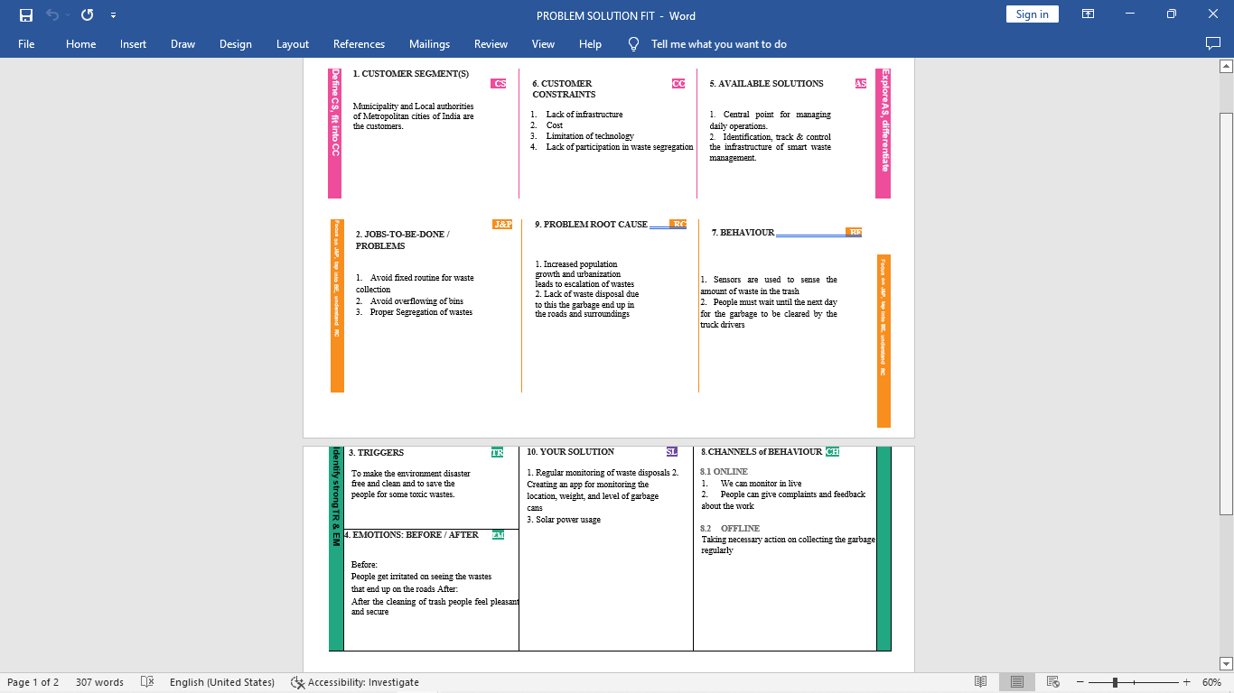

**PROPOSED SOLUTION:**

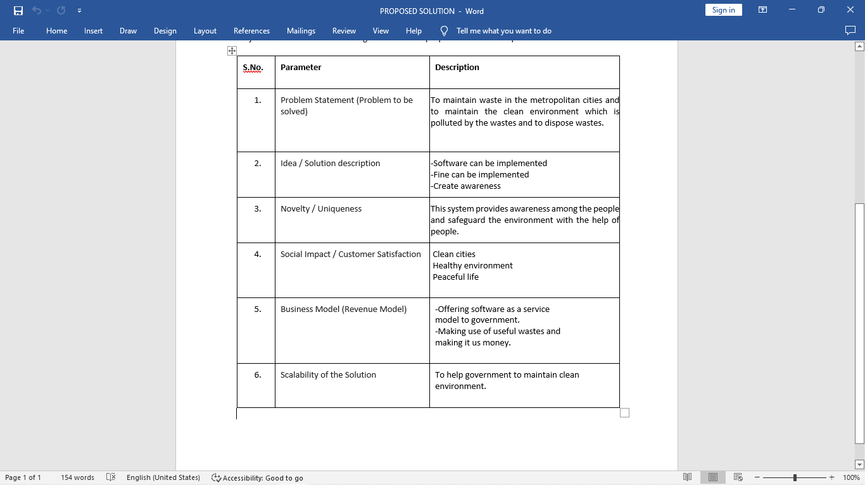

**SOLUTION ARCHITECTURE:**

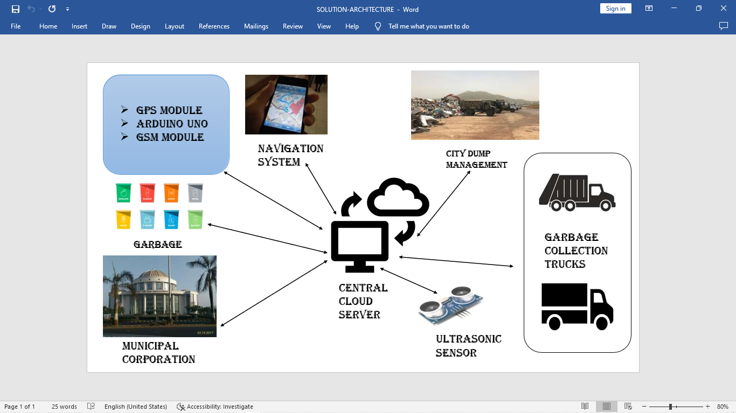

**PHASE 2**

**CUSTOMER JOURNEY:**

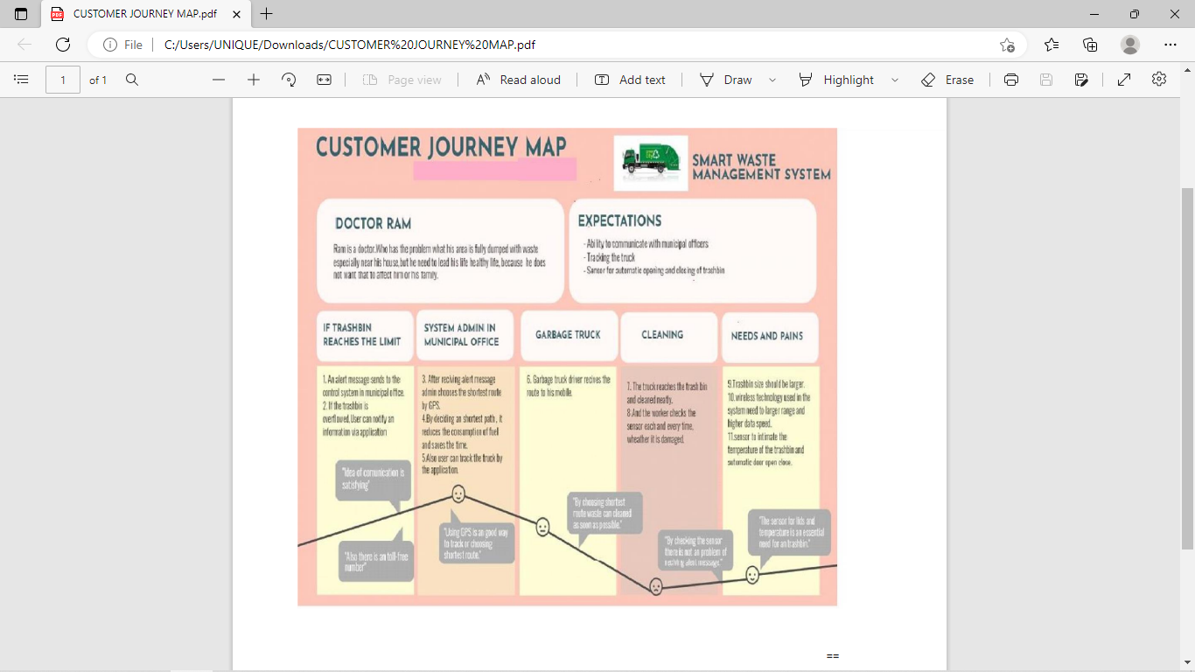

**DATA FLOW DIAGRAM:**

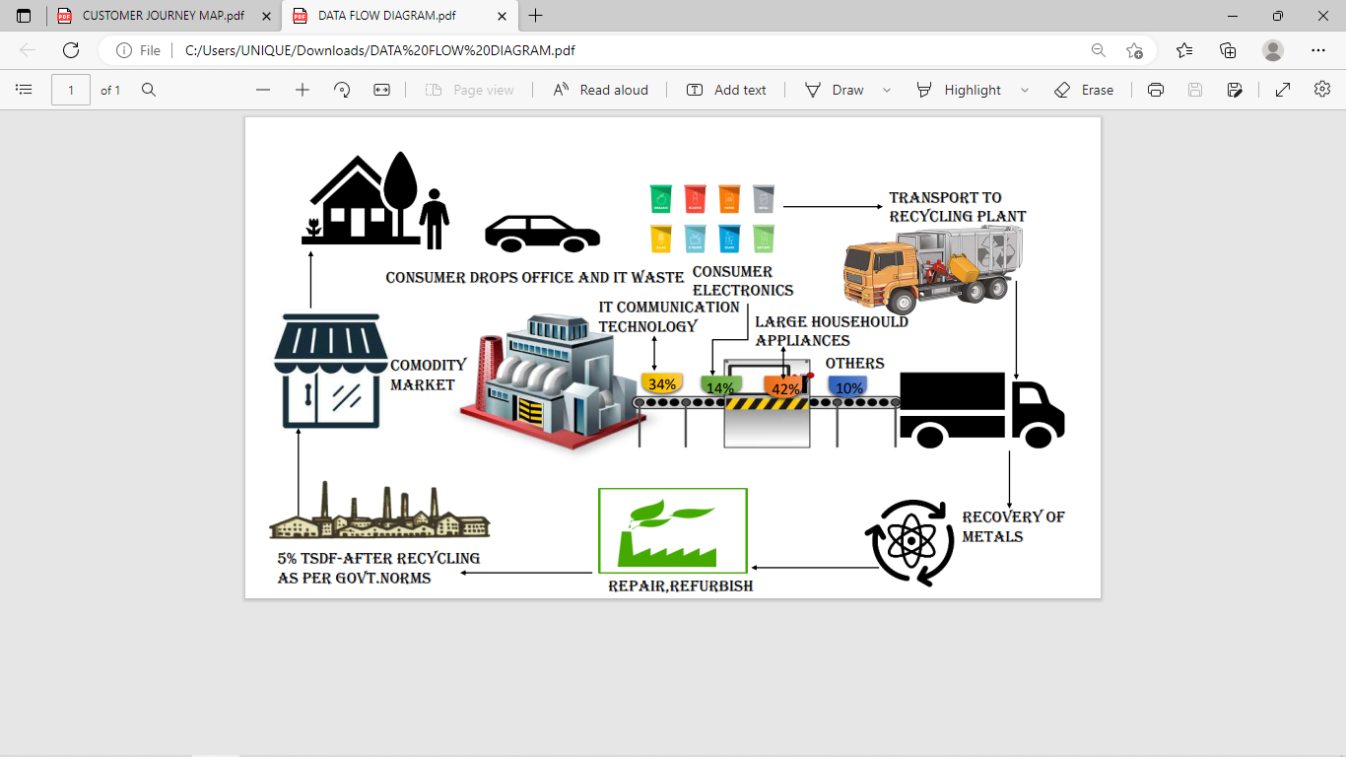

**FUNCTIONAL REQUIREMENT:**

**Objective:**

The main objective of the smart waste management system is to develop a new type of waste management in government and individual waste treatment industries to gather waste material for the purpose of recycling and disposal of human waste products, electronics, medical to be disposed safely with usage of multiple modern developed web based user management and IOT devices based on the garbage bin.

**End result:**

The garbage bin consist of IOT devices at the top and bottom of the garbage bin which helps to analyze the weight and the amount of space in the dustbin which helps the worker and the waste management acquire date of waste products dropped by people at individual location in order to maintain and collect and cover a vast area of the city with the report given by the garbage bins.

**Focus:**

The customer or the person who proceeds to drop and waste in the dustbin must notify the type of waste was to dropped. The method will helps prevention of liquid matter which to dropped which may cause damage to the IOT Devices in bottom. Since the specification known only to the Smart city management team , they must advise the worker to conduct a journey to analyze how people drop their waste based on their activities which help the worker to advise the customer to be aware of the device inside the dustbin.

**Essentiality :**

The IOT device must send data to the Smart city waste management team in order to check the level of the dustin space and the area location where it currently moves , it must send indication level time to time for filling of the waste products ,the localized dustbin may vary from small dustbin to bigger truck as the IOT devices may eligible for both of them.

**Types :**

The dustbin distributed in all areas of region of the city and the dustbin will minimize the amount taken to manage by the customer . It varies from individual dustbin to Business development area manageable area dustbin where raw materials calculated and disposed easily and safely and service will be in both customer and to medicals units in allowance of the customer . The dustbin manages all types of units and waste products which the IOT helps the manage the space and indication of another in case of full of the one's dustbin which customer allocate another dustbin to provide service to area within the fraction of seconds

**Technology Architecture:**

The Deliverable shall include the architectural diagram as below and the information as per the table1 & table 2

Example: Order processing during pandemics for offline mode

**Table-1 : Components & Technologies:**

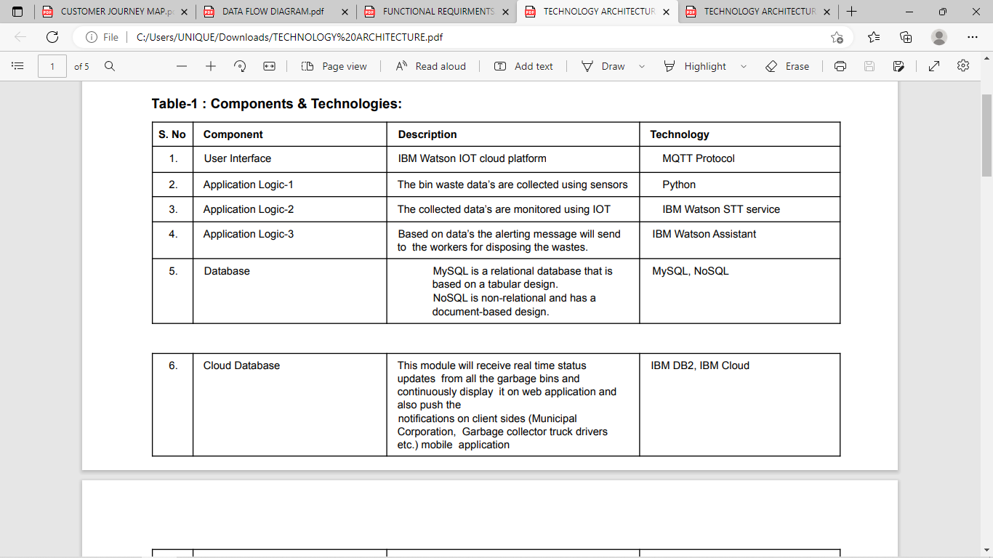

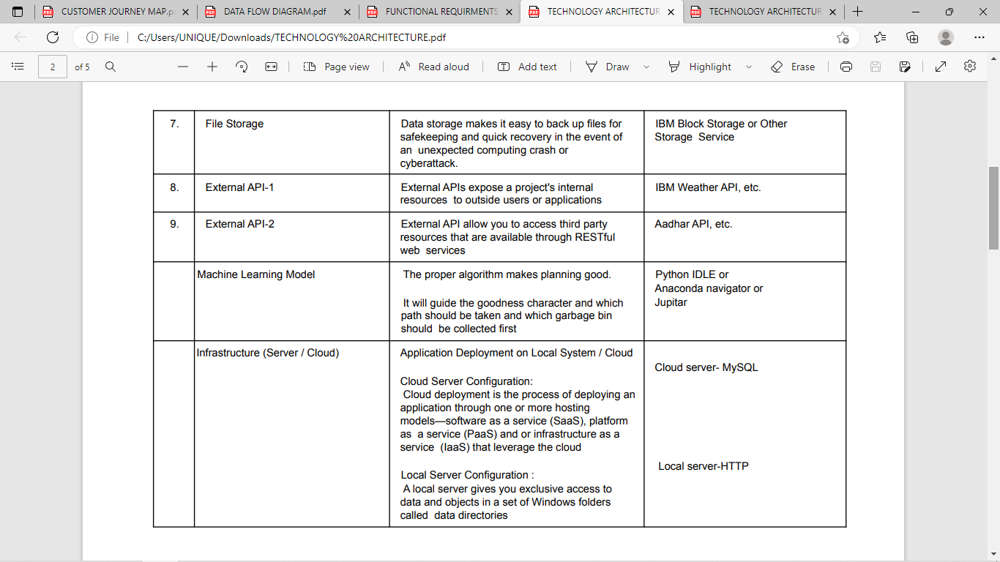

**TABLE- 2: APPLICATION CHARACTERISTICS**

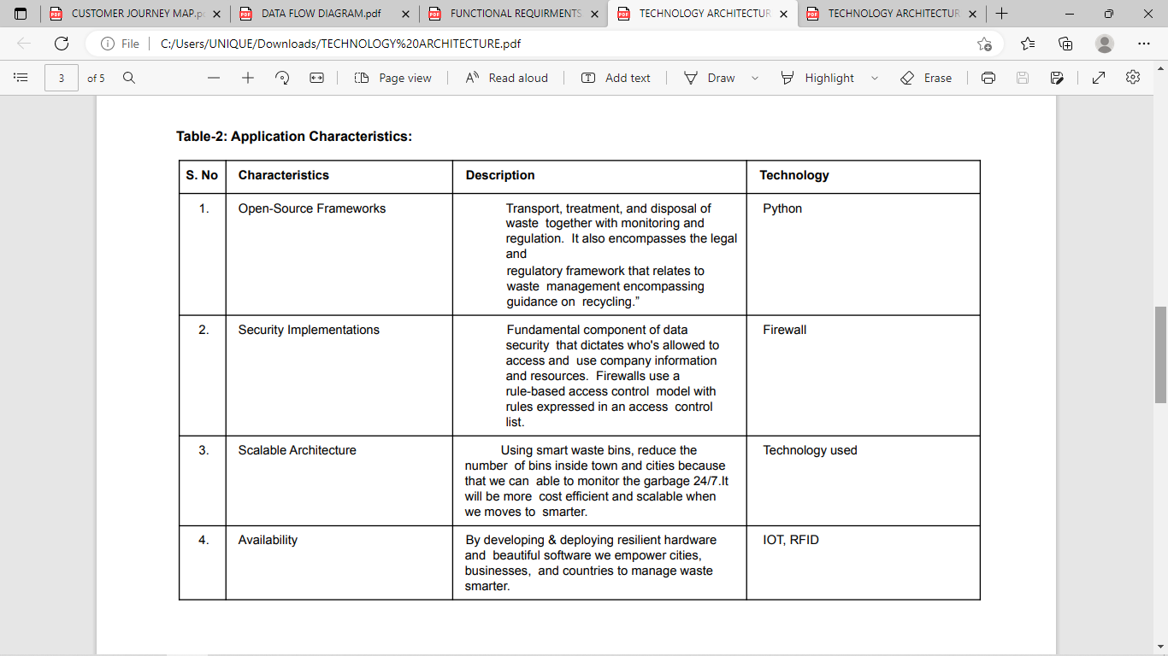

**PROJECT DEVELOPMENT PHASE:**

**SPRINT-1**

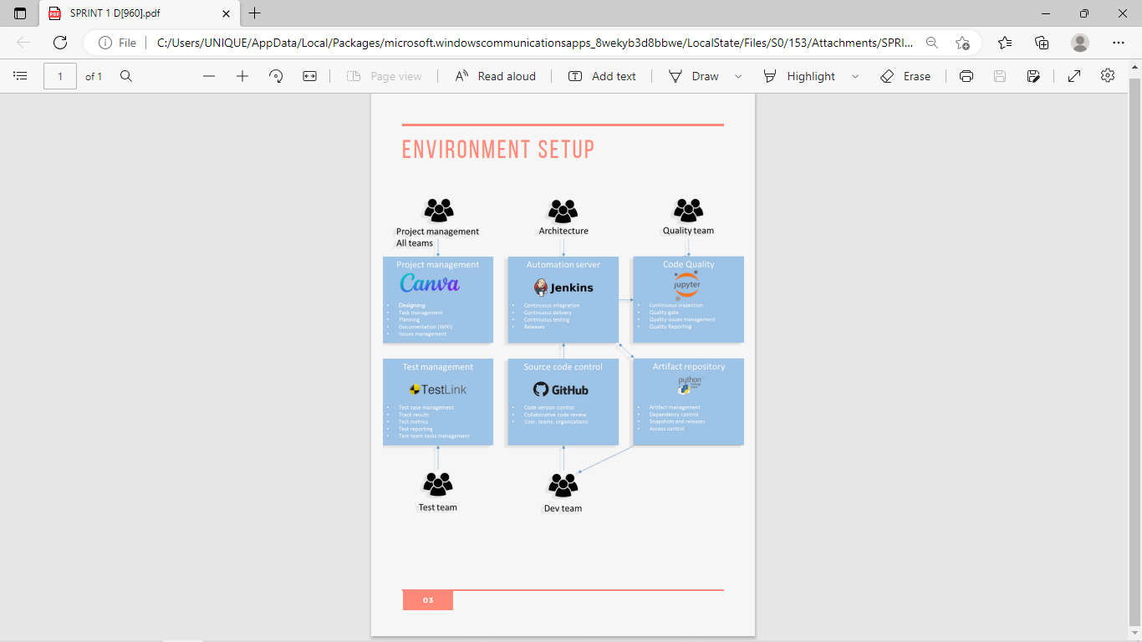

**SPRINT-2**

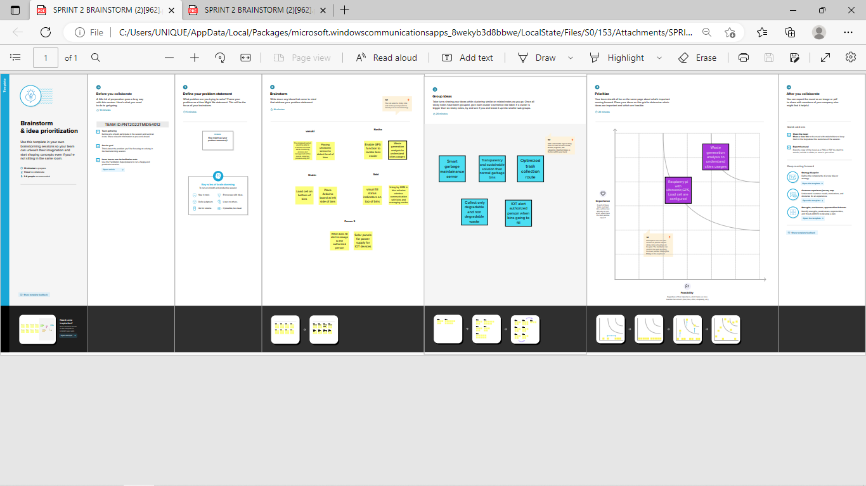

**SPRINT-3**

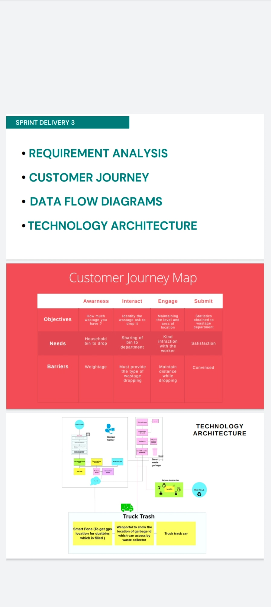

**SPRINT-4**

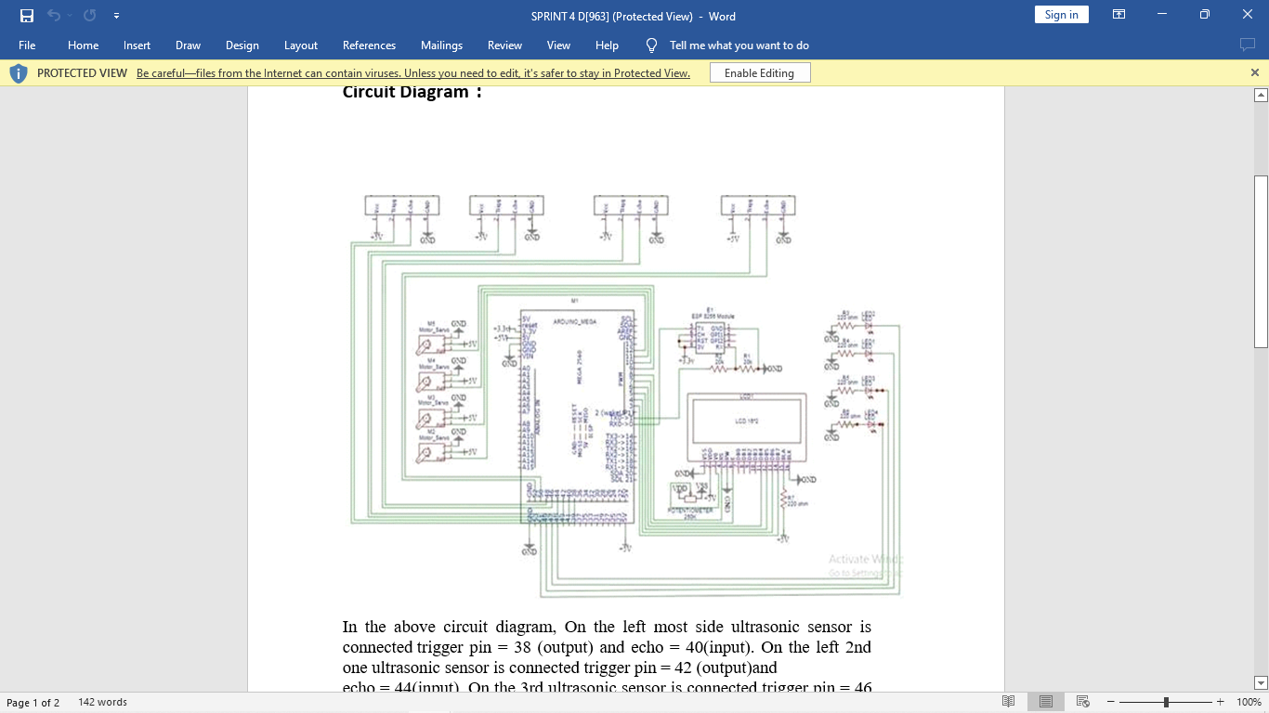

In the above circuit diagram, On the left most side ultrasonic sensor is connected trigger pin = 38 (output) and echo = 40(input). On the left 2nd one ultrasonic sensor is connected trigger pin = 42 (output)and

echo = 44(input). On the 3rd ultrasonic sensor is connected trigger pin = 46 (output)and echo = 48(input). On the right most side ultrasonic sensor is connected trigger pin = 52 (output)and echo = 50(input). M2, M3, M4, M5, are servo motors. At M2, pwm=12. At M3, pwm=11. At M4, pwm=10. At M5, pwm=9. LED 2=51 LED 1 =49 LED 3 = 47 LED 4 =45. We use esp 8266. So the tx is connected to rx 0. And the rx is connected to tx 0. Then the other pin of the 16 *2 LED display.

**DISCUSSION:**

It became evident from the primary studies that the SWM concept needed to be divided into city-level SWM system descriptions and low-level element descriptions—especially the SGB studies. Both levels use technologies to provide different services. At the SWM level, various communication technologies, from very short-range technologies to Internet - wide communication, are proposed for the transfer of information. Apart from the communication with the local elements of the SWM system, such as SGBs , the system- level communication mainly utilizes Wi-Fi and mobile network for data transfer. The data are then used in the SWM system to provide various services.

Most parts of the systems analyse real-time data (used in most routing and optimization systems, business cases, and basic SWM systems). The use of the analysed historical data is much less common. In many of the city level studies, the data are first analysed, and then these data (or part thereof) are provided through interfaces—for example, the city dashboard—for various stakeholders. The city dashboard could, for example, display the locations of SGBs, information about SGBs (type of waste, fullness, etc.), location of trucks, truck routes, and the location of waste-processing facilities and dumps. The city dashboard can also be used as a part of routing planning and optimization system for drivers, information support systems for citizens, and information support systems for dispatchers. In addition to the city dashboard, SWM systems also provide information support for various stakeholders: citizens, city administration, waste department, drivers, dispatchers, waste disposal organizations, corresponding authorities, and emergency services.

In most cases, the SWM systems aim to optimize the waste collection processes by organizing timely garbage disposal while minimizing costs (fuel and working hours of drivers) and improving the environmental situation. The most commonly used services for this are route planning, optimization and scheduling (static or dynamic). Some authors also offer optimization of the location of SGBs, typically in combination with route optimization or planning. Door-to-door garbage collection is used in several SWM systems with the aim of improving urban ecology.

**CONCLUSION:**

We learned from the analysis that effective organization of waste collection and processing can be considered at different levels: high (city) level and low (SGB) level. In most cases, the city-level SWM systems aim to optimize waste collection processes by organizing timely garbage disposal while minimizing costs (fuel and working hours of drivers) and improving the environmental situation. As such, the proposed SWM systems can be roughly divided into a) systems that improve internal processes and b) systems that disseminate the information by providing a holistic real-time view. A small number of studies propose economic and ecological features for the SWM system. The economic features can be either incentives (e.g., rewards) or punishments (e.g., payments) based. The ecological aspects are linked to waste segregation and measuring environmental impact. The SGB level of SWM systems focuses on various implementations of SGBs and SWM systems with SGB-related services. The primary studies present a wide variety of sensors and actuators, as well as services, based on the data provided by the sensors.

We also identified research gaps in the field of SWM systems based on our analysis of the literature. We single out the following areas: 1) optimization of the garbage collection process, reduction of labour and resource costs, increase in efficiency and comfort of citizens; 2) improvement of the ecological situation in the city; 3) increasing environmental awareness and motivation of the citizens; 4) informing city authorities: providing big picture, informing about existing problems and needs, forecasting. The main weakness of the current studies (and thus also a gap) is that none of them aims to propose a general holistic view at any level of operation. Our results on SWM stakeholders, information, and services can be used as a basis for the creation of a general system-level approach and the standardization of information syntax and semantics.

**REFERENCE:**

[1] V. R. S. Cheela and B. Dubey, ‘‘Review of application of systems engi neering approaches in development of integrated solid waste management for a smart city,’’ in *Water Resources and Environmental Engineering II*. Singapore: Springer, 2019, doi: 10.1007/978-981-13-2038-5_16.

[2] Esmaeilian, B. Wang, K. Lewis, F. Duarte, C. Ratti, and S. Behdad, ‘‘The future of waste management in smart and sustainable cities: A review and concept paper,’’ *Waste Manage.*, vol. 81, pp. 177–195, Nov. 2018, doi: 10.1016/j.wasman.2018.09.047.

[3] K. Dhyani and N. Patel, ‘‘Smart trash monitoring and segregation system using emerging technology—A survey,’’ in *Proc. Int. Conf. Adv. Inform. Comput. Res.*, 2019, pp. 667–674, doi: 10.1007/978-981-13-3140-4_60.

[4] M. Topaloglu, F. Yarkin, and T. Kaya, ‘‘Solid waste collection system selection for smart cities based on a type-2 fuzzy multi-criteria decision technique,’’ *Soft Comput.*, vol. 22, no. 15, pp. 4879–4890, Aug. 2018, doi: 10.1007/S00500-018-3232-8.

[5] M. S. Chaudhari, B. Patil, and V. Raut, ‘‘IoT based waste collection management system for smart cities: An overview,’’ in *Proc. 3rd Int. Conf. Comput. Methodologies Commun. (ICCMC)*, Mar. 2019, pp. 802–805, doi: 10.1109/ICCMC.2019.8819776.

[6] S. Kitchenham and B. Charters, ‘‘Guidelines for performing systematic literature reviews in software engineering,’’ Softw. Eng. Group School Comput. Sci., Math. Keele Univ. Keele, Staffs, U.K., Dept. Comput. Sci., Univ. Durham, Durham, U.K., EBSE Tech. Rep. EBSE-2007-01, 2007.

[7] F. Shull, J. Singer, and D. I. K. Sjøberg, Eds., *Guide to Advanced Empirical Software Engineering*. London, U.K.: Springer, 2008, doi: 10.1007/978-1-84800-044-5_11.

[8] J. Zeng, J. Zhang, and Y. Liu, ‘‘Blockchain based smart park: Clean ing management,’’ in *Proc. 2nd Int. Conf. Blockchain Technol. Appl.*, Dec. 2019, pp. 53–58, doi: 10.1145/3376044.3376046.

[9] S. Li, K. Sun, M. Qi, and J. Liu, ‘‘Design of beverage packaging identification and recycling system based on zedboard,’’ in *Proc. 7th Int. Conf. Inf. Technol., IoT Smart City*, Dec. 2019, pp. 175–180, doi: 10.1145/3377170.3377219.

[10] S. Faye, F. Melakessou, W. Mtalaa, P. Gautier, N. AlNaffakh, and D. Khadraoui, ‘‘SWAM: A novel smart waste management approach for businesses using IoT,’’ in *Proc. 1st ACM Int. Workshop Technol. Enablers Innov. Appl. Smart Cities Communities*, Nov. 2019, pp. 38–45, doi: 10.1145/3364544.3364824.

[11] S. K. T. Utomo, T. Hamada, and N. Koshizuka, ‘‘Low-energy smart trash bin architecture for dynamic waste collection system,’’ in *Proc. 2nd Int. Conf. Future Netw. Distrib. Syst.*, Jun. 2018, pp. 1–7, doi: 10.1145/3231053.3231077.

[12] P. Fedchenkov, A. Zaslavsky, and I. Sosunova, ‘‘Enabling smart waste management with sensorized garbage bins and low power data commu nications network,’’ in *Proc. 7th Int. Conf. Internet Things*, Oct. 2017, pp. 1– 2, doi: 10.1145/3131542.3140264.

[13] J. Naskova, ‘‘RecycHongs: Mobile app co-design,’’ in *Proc. ACM Conf. Companion Publication Designing Interact. Syst.*, Jun. 2017, pp. 337–340, doi: 10.1145/3064857.3079188.

[14] S. Sharmin and S. T. Al-Amin, ‘‘A cloud-based dynamic waste man agement system for smart cities,’’ in *Proc. 7th Annu. Symp. Comput. Develop.*, Nov. 2016, pp. 1–4, doi: 10.1145/3001913.3006629.

[15] P. J. Shah, T. Anagnostopoulos, A. Zaslavsky, and S. Behdad, ‘‘A stochas tic optimization framework for planning of waste collection and value recovery operations in smart and sustainable cities,’’ *Waste Manage.*, vol. 78, pp. 104–114, Aug. 2018.

[16] Z. Wen, S. Hu, D. De Clercq, M. B. Beck, H. Zhang, H. Zhang, F. Fei, and J. Liu, ‘‘Design, implementation, and evaluation of an Internet of Things (IoT) network system for restaurant food waste management,’’ *Waste Manage.*, vol. 73, pp. 26–38, Mar. 2018, doi: 10.1016/j.wasman.2017.11.054.

[17] V. Elia, M. G. Gnoni, and F. Tornese, ‘‘Improving logistic effi ciency of WEEE collection through dynamic scheduling using simu lation modeling,’’ *Waste Manage.*, vol. 72, pp. 78–86, Feb. 2018, doi: 10.1016/j.wasman.2017.11.016.

[18] T. R. P. Ramos, C. S. de Morais, and A. P. Barbosa-Póvoa, ‘‘The smart waste collection routing problem: Alternative operational management approaches,’’ *Expert Syst. Appl.*, vol. 103, pp. 146–158, Aug. 2018, doi: 10.1016/j.eswa.2018.03.001.

[19] S. Digiesi, F. Facchini, G. Mossa, G. Mummolo, and R. Verriello, ‘‘A cyber–based DSS for a low carbon integrated waste management sys tem in a smart city,’’ *IFAC-PapersOnLine*, vol. 48, no. 3, pp. 2356–2361, 2015, doi: 10.1016/j.ifacol.2015.06.440.

[20] T. Anagnostopoulos, K. Kolomvatsos, C. Anagnostopoulos, A. Zaslavsky, and S. Hadjiefthymiades, ‘‘Assessing dynamic models for high priority waste collection in smart cities,’’ *J. Syst. Softw.*, vol. 110, pp. 178–192, Dec. 2015, doi: 10.1016/j.jss.2015.08.049.